 | 12.1.36 Editors - Geometry Nodes Editor - Header - Add Menu - Volume - Read
Table of content
Detailed table of content 1
Add menu - Volume - Read 2
Get Named Grid 2
Grid Info 3
Voxel Index 3

Detailed table of content
Detailed table of content
Detailed table of content 1
Add menu - Volume - Read 2
Get Named Grid 2
Inputs 2
Volume 2
Name 2
Remove 2
Properties 2
Data Type 2
Output 2
Volume 2
Grid 2
Grid Info 3
Inputs 3
Grid 3
Properties 3
Data type 3
Output 3
Transform 3
Background Value 3
Voxel Index 3
Outputs 3
X / Y / Z 3
Tile subpanel 3
Is Tile 3
Extend X / Y / Z 3

´

Add menu - Volume - Read
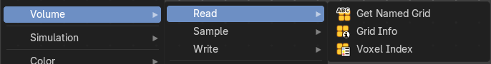
Here you find nodes to modify the volume.

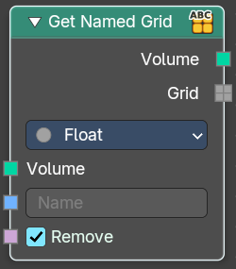
Get Named Grid
Get volume grid from a volume geometry with the specified name

Inputs

Volume
The input volume.

Name
The name of the grid.

Remove
Removes the grid from the volume after retreive.

Properties

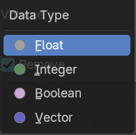
Data Type
The type of data stored in the grid. It determines both, the expected data type of the Grid output, and how it can be used in subsequent nodes.

Output

Volume
The output grid.

Grid
The extracted grid.

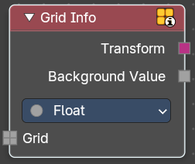
Grid Info
Retreive informations about a grid.

Inputs

Grid
Standard geometry input.

Properties

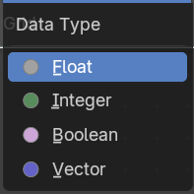
Data type
The data type to retreive.

Output

Transform
Transform from grid index space to object space.

Background Value
Default value outside of grid voxels.

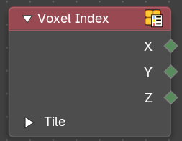
Voxel Index
Retreive the integer coordinates of the voxel that the field is evaluated on.

Outputs

X / Y / Z
Vector 3 output of the voxel.

Tile subpanel

Is Tile
True when the field is evaluated on a tile.

Extend X / Y / Z
Number of voxels in the corresponding direction. Or 1 if the field is evaluated at a voxel.

